Lullaby
When I was a little girl, for years, my dad would tuck me in bed and sing me Lullaby. I’m not sure of the official lyrics to this song, but here is what I fell asleep to:

Lullaby…go to sleep…for your daddy is watching….
Lullaby…go to sleep…for your daddy is here.
Lullaby …go to sleep…for your daddy is watching…
Lullaby…go to sleep…for your daddy loves you.

My dad would sing these 4 lines over and over again until I eventually drifted into a coma like state and was completely at peace. Most times I would be conscience enough to sense him leave my side, and tip toe out the room. I smiled inwardly, at the thought of him proudly believing he successfully got me to sleep.
I know I was little, but I remember it vividly.

Many years later, when I too became a parent, I instinctively found myself singing this same song, with modification to one word:

Lullaby…go to sleep…for your mommy is watching….
Lullaby…go to sleep…for your mommy is here.
Lullaby …go to sleep…for your mommy is watching…
Lullaby…go to sleep…for your mommy loves you.

As I would tip toe out of my son’s room, I truly understood the heart felt satisfaction my Dad must have experienced when you know your child is at peace, and you helped them get there.

On January 18, 2016 my dad suddenly collapsed into a coma from a blood clot that had traveled to his brain. I stood over him in the ER looking at his Cat Scan while listening to the doctor explain that the bleeding was massive. My dad could possibly survive, but the pressure on his brain was great. It could be released by cracking the skull, but irreparable damage had surely been done, and he would most likely be in a vegetative state for the remainder of his life.

Per my parent’s Advanced Directive, it was his wish to not resuscitate or extend life beyond what his own body could handle. So, the decision to allow himself to shut down and drift from this life to the next, was already made years ago, by him.

I stood over my dad, holding his hand, and kissing his forehead as he lay in the hospital bed. As tragic and devastating as it was, he looked so peaceful. He looked just like he did whenever he would fall asleep watching television in his chair: his head cocked to one side, mouth open, and quiet audible breathing to be heard.

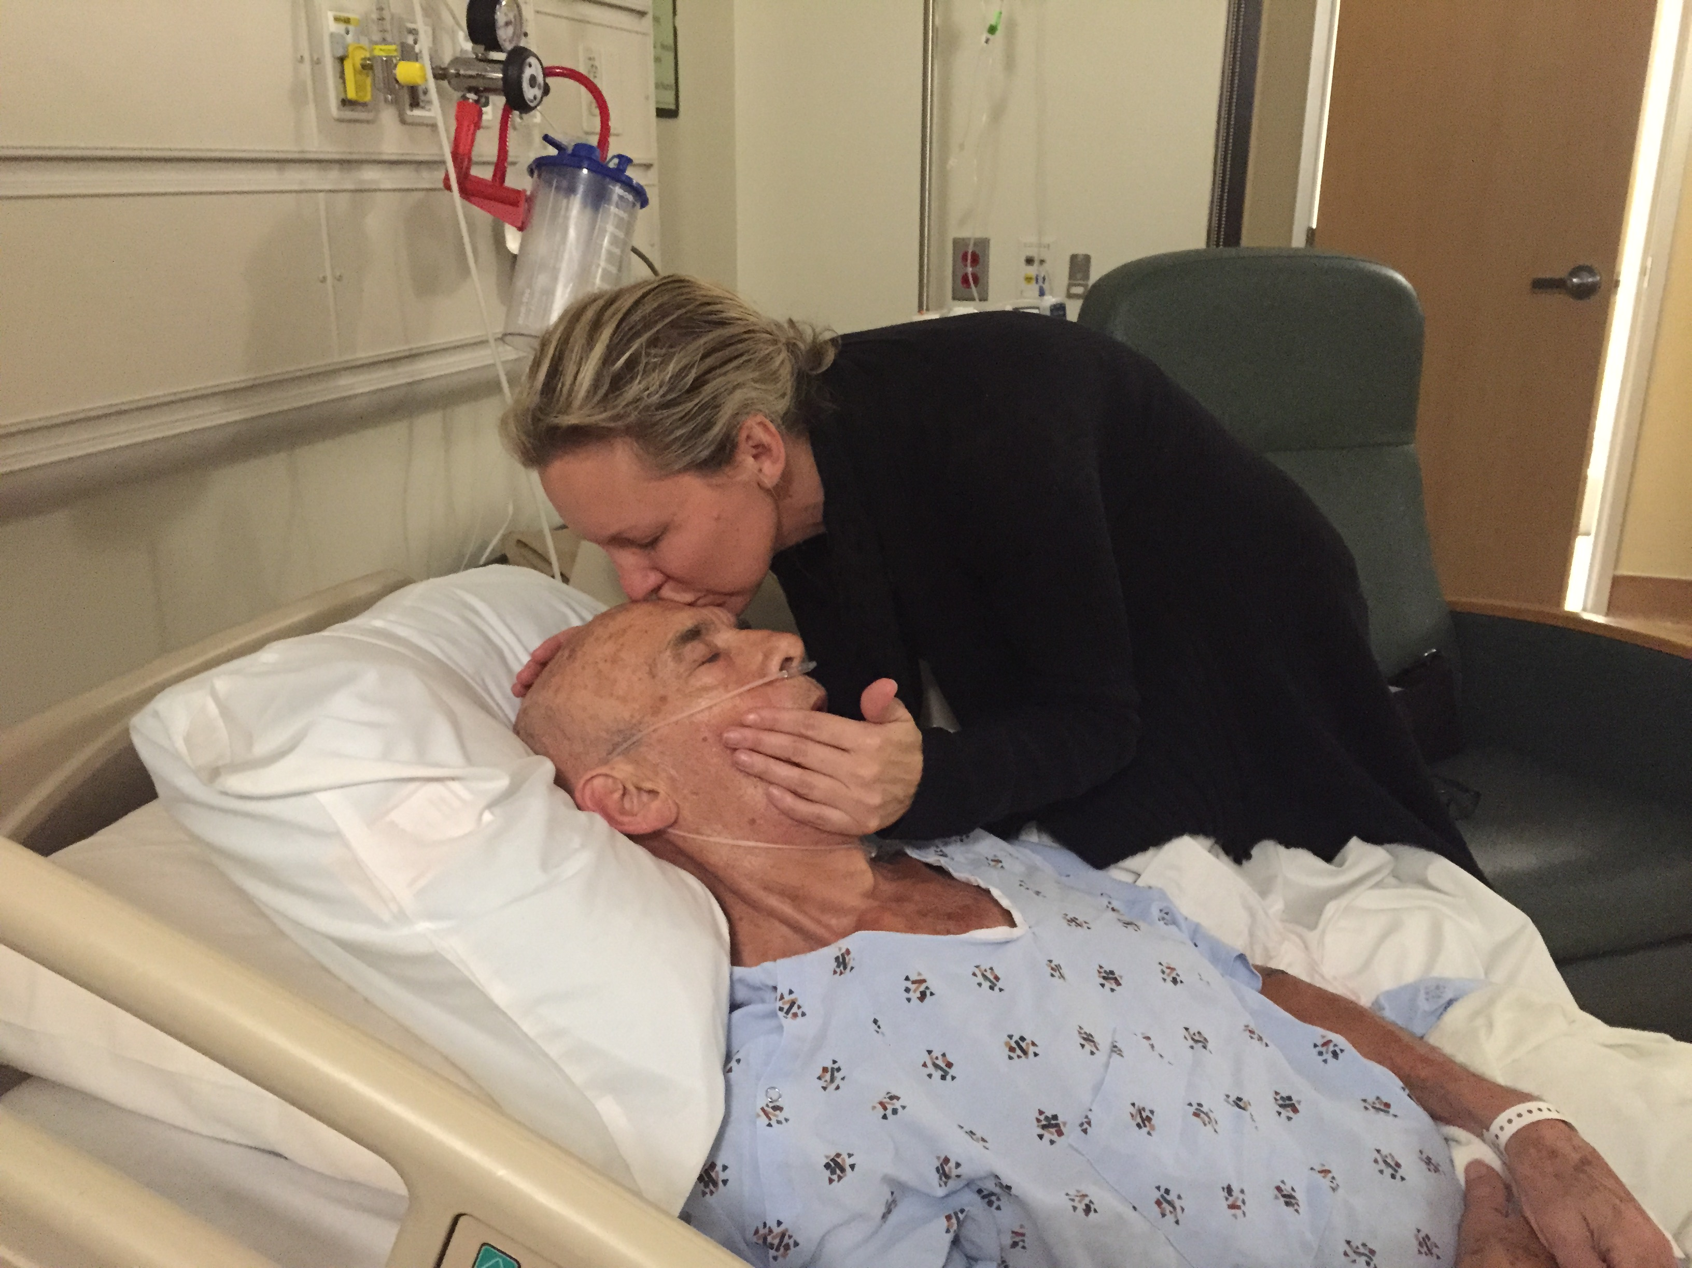

What happened next I was not prepared for. The song… our song… the lullaby; it began to chime from inside the hospital room. I literally shook my head, in disbelief, for surely I was delusional and the sound was just in my imagination. My sister, who was standing on the other side of the bed, looked at me with wide tearful eyes, I knew she heard it too. I glanced back at my dad, sleeping so peacefully and I began to mentally place the words to the lullaby in accordance to the chimes. Except this time, the song was being sung to him. Not by me, but by his Heavenly Father…

Lullaby…go to sleep…for your Father is watching….
Lullaby…go to sleep…for your Savior is here.
Lullaby …go to sleep…for your Father is watching…
Lullaby…go to sleep…for your Daddy loves you.

A moment later, a nurse walks in and casually asks, “Did you here the lullaby chimes?” I just stared back at her; a loss for words. She smiled and continued, “Lullaby chimes play through out the whole hospital, each time a baby is born in our delivery room.”

God’s timing is always perfect. In that moment I could feel my Father’s arms around me as I placed mine around my dad.
Exactly one week later, my dad finished sleeping …and I’m sure woke to see the face of the One who is always watching, is always here, and always loves you.

